AWS Advance Assignment Day 13 LU:
Question 1: Working with RDS
Task 1: Create an RDS Database Instance
To create RDS Database instance, we first create the rds security group as
below:
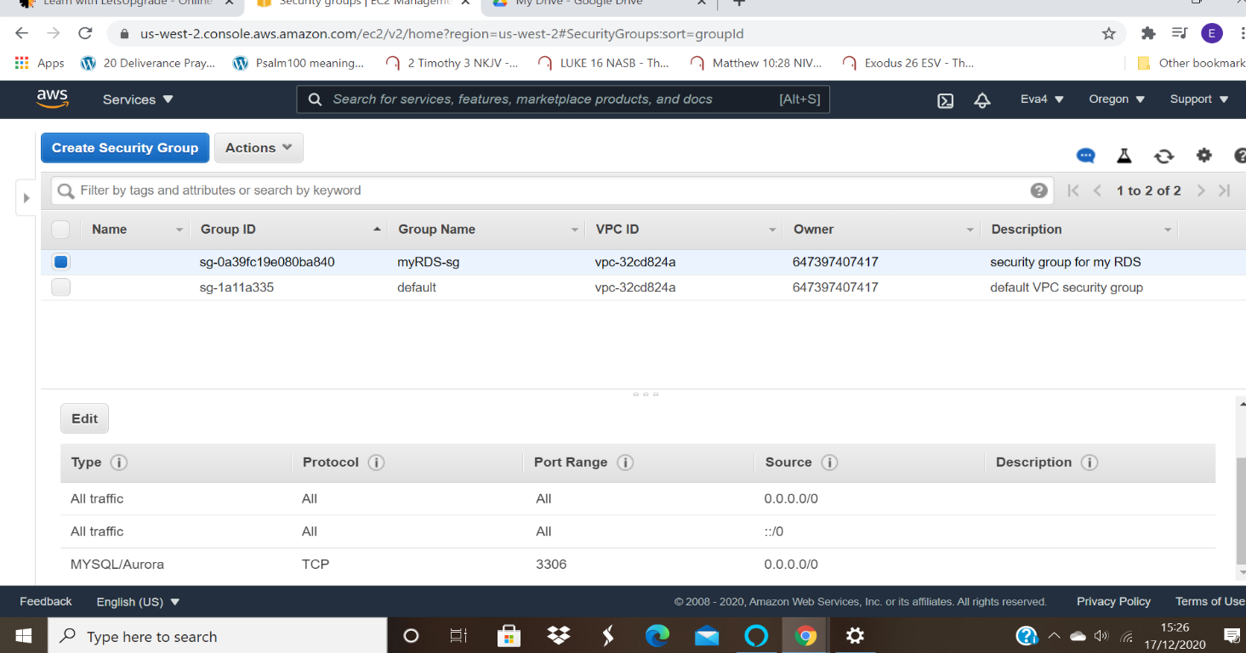

● Ss1: Db instance page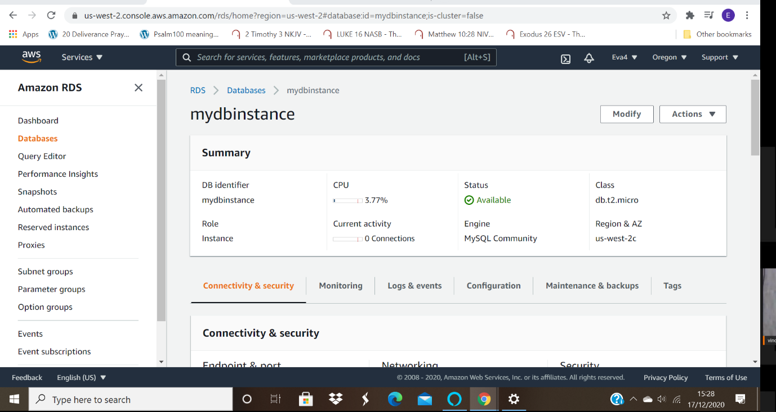

● Ss2: DB instance details
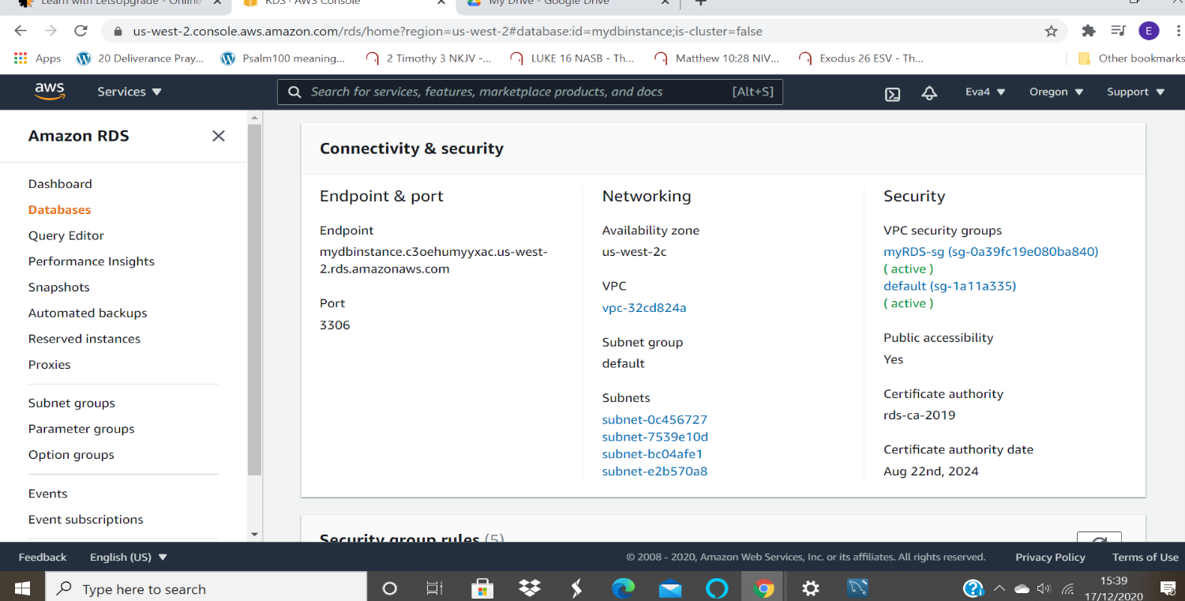

● Ss3: security group inbound rules+multiple changes made to a security group
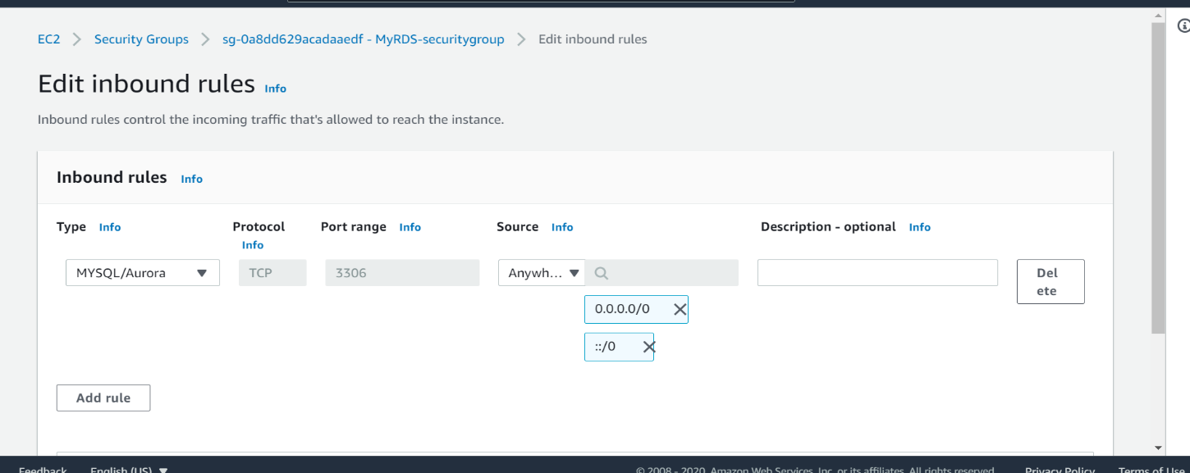

Task 2: Connecting to RDS Database on a DB Instance using the MySQL Workbench

● Ss4: sql workbench endpoint added and secret vault entry
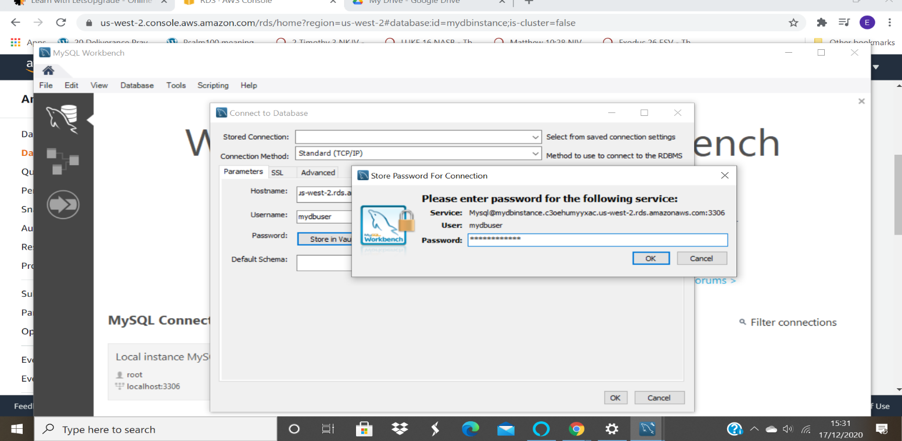

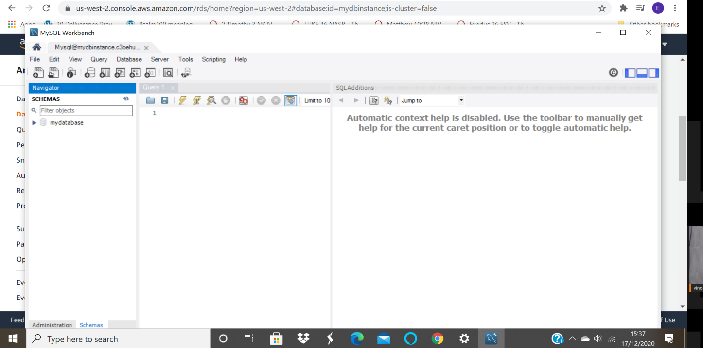

Task 3: Test Connection
● Ss6: confirm connectivity screen
